 CU1900305

Toqa Mahmoud

CU1900305

Intro to Web Development and Database Systems

KH4056CEM

Table of Contents

introduction 3

client – side 3

databases 3

architecture of the website 5

ide and tools 5

website functionalities 6

user functionalities 6

restrictions 6

admin functionalities 6

restrictions 6

UI functions 6

javascript 7

php 12

login function 12

signup function 13

ordering function 15

admin functions 15

adding 15

updating 18

delete 20

sessions 21

cookies 21

prototype of the website 22

Conclusion 28

# introduction

Online ordering services eases the process on many individuals and family and I believe having such a system in Egypt will tremendously enhance the community’s needs. Therefore, in this coursework, I came with the idea of developing a CRUD website to give users the capability of ordering home services online. CRUD stands for create, read, update and delete. The website was precisely designed by optimal use of html, css, php, and mysql. This report aims to provide detailed analysis of the resulting website. It shows how the website was conducted from scratch.

# client – side

Needing home services such as gardening, handymen, cleaning, etc. is always a necessity in all homes. Therefore, offering the capability of ordering these services online in minutes is significantly an amazing business to start. To guarantee professional service and higher quality the following procedure will be implemented.

The website first displays the landing page and then the client has the option to start the process by logging in (username and password) in the website. If the user is new, then they have to register by inputting (name, username, password, and confirmation password) to gain access to the website. After that, they will have access to all the categories and services available and can order any service by filling a form that includes (name, contact, email, and address). After that, the order is forwarded to the admins, which are in charge of checking and updating the status of the order, whether it is ordered, on delivery, delivered, or cancelled.

# databases

|  |  |  |
| --- | --- | --- |
| users | | |
| primary | id | Int(10) |
|  | user_name | Varchar(255) |
|  | password | Varchar(255) |
|  | name | Varchar(255) |

|  |  |  |
| --- | --- | --- |
| tbl_admin | | |
| primary | id | Int(11) |
|  | full_name | Varchar(100) |
|  | username | Varchar(100) |
|  | password | Varchar(255) |

|  |  |  |
| --- | --- | --- |
| tbl_category | | |
| primary | id | Int(11) |
|  | title | Varchar(100) |
|  | Image_name | Varchar(255) |
|  | featured | Varchar(10) |
|  | active | Varchar(10) |

|  |  |  |
| --- | --- | --- |
| tbl_service | | |
| primary | id | Int(11) |
|  | title | Varchar(100) |
|  | description | text |
|  | price | decimal(10,2) |
|  | Image_name | Varchar(255) |
|  | Category_id | Int(10) |
|  | featured | Varchar(10) |
|  | active | Varchar(10) |

|  |  |  |
| --- | --- | --- |
| tbl_order | | |
| primary | id | Int(10) |
|  | service | Varchar(150) |
|  | price | decimal(10,2) |
|  | q | int(11) |
|  | total | decimal(10,2) |
|  | order_date | datetime |
|  | status | Varchar(50) |
|  | customer_name | Varchar(150) |
|  | customer_contact | Varchar(20) |
|  | customer_email | Varchar(150) |
|  | customer_address | Varchar(255) |

The data base diagram of the online order services contains the scope of the system. This project involves two main actors, the user and the admin.

The user: the user represent as the primary actor for this system, the system offers online home services to be delivered to different locations.

The admin: Admin of the system is responsible to several interaction with the system to reach the objectives. As an example, the admin can delete the customer order at any time with proper reasoning or add more categories.

# architecture of the website

This section shows the coding layer of the website, which are between User Interface (UI) and Database.

The Presentation Layer: this is the front-end where users are authorized to access through a browser. It includes the UI process components. I used three languages in this layer - HTML, CSS, and JavaScript.

* **HTTP**: Hypertext Markup Language is the standard markup language for documents designed to be displayed in a web browser.
* **CSS**: Cascading Style Sheets is a style sheet language used for describing the presentation of a document written in a markup language such as HTML
* **JavaScript**: is a programming language that conforms to the ECMAScript specification. JavaScript is high-level, often just-in-time compiled, and multi-paradigm

The Application Layer: it is on the back-end where user requests are received. Data and requests are sent through the back end and are implemented by PHP logic.

* **PHP**: Hypertext Preprocessor is a widely-used open source general-purpose scripting language that is especially suited for web development and can be embedded into HTML.

The Persistence Layer: this is on the back-end where it can also be called the storage or data access layer, it is a centralized location that get all data functions. This layer is connected to the business layer so the functions know which database to connect to and retrieve data from as well. The data storage infrastructure includes a server and a Database Management System, software to communicate with the database itself, applications, and user interfaces to obtain data and parse it. In my case, I used Phpmyadmin (XAMPP) and SQL.

* **Phpmyadmin**: is a PHP software tool, made to manage the administration of MySQL over a browser. It supports a wide range of operations on MySQL. Often used operations (managing databases, tables, columns, relations, indexes, users, permissions, etc). The default port for MySQL is 3306.
* **XAMPP**: is a free and open-source cross-platform web server solution stack package developed by Apache Friends, consisting mainly of the Apache HTTP Server, MariaDB database, and interpreters for scripts written in the PHP. The default port of xampp Apache server is 80.
* **SQL**: Structured Query Language is a domain-specific language used in programming and designed for handling data in a  database management system.

# ide and tools

Visual Studio Code: I used Visual Studio Code as an Integrated Development Environment (IDE) to develop the website.

SQL Server: I stored the database in to SQL server.

# website functionalities

## user functionalities

* The user can create an account by registering and inputting their data such as name, username, and password.
* After creating an account, the user can login the website.
* After logging in, the user can place an order of any chosen system on the website.
* The user can logout.

### restrictions

* Without logging in first, the user cannot access any website page other than the index.
* The user cannot access the admin panel, in any case.

## admin functionalities

* The admin can login the admin panel.
* The admin can add or delete another admin.
* The admin can add, update, and delete categories.
* The admin can add, update, and delete services.
* The admin can update orders, such as changing the order status from ordered to delivered.
* The admin can logout.

### restrictions

* Without logging in first, the admin cannot access any of the admin panel pages.

# UI functions

While designing the user interface I started by the header and footer and saved both in different files. I did this because both of they will be used in every page, which is time efficient and made the code more organized. Moreover, I defined variables for the most used commands and saved them in a file called, constants, in order to ease the process of writing the code.

* The constants include the following variables. This page is included in all the other pages by this command. <?php include('config/constants.php') ?>

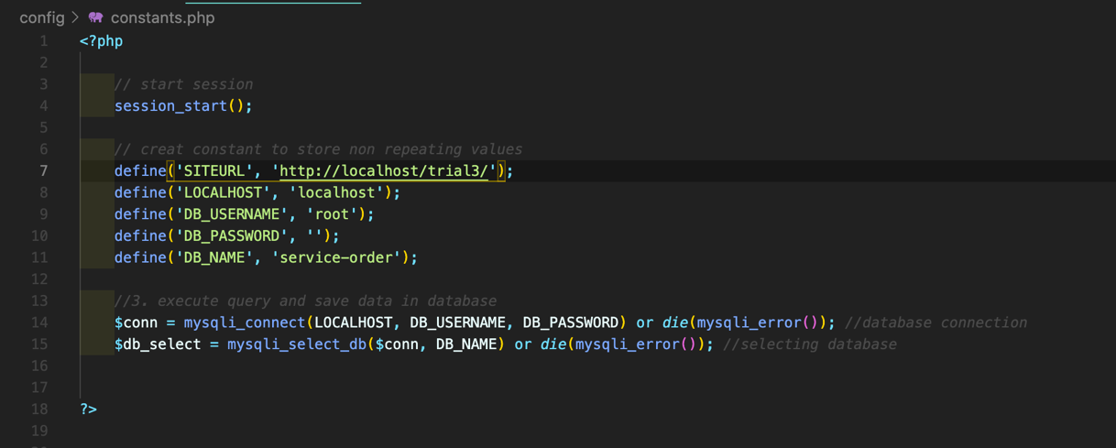

## javascript

Now, let us start by the JavaScript functions. The first function’s responsibility is to rotate the menu icon when clicked and then drop down the menu, when the browser size is adjusted.

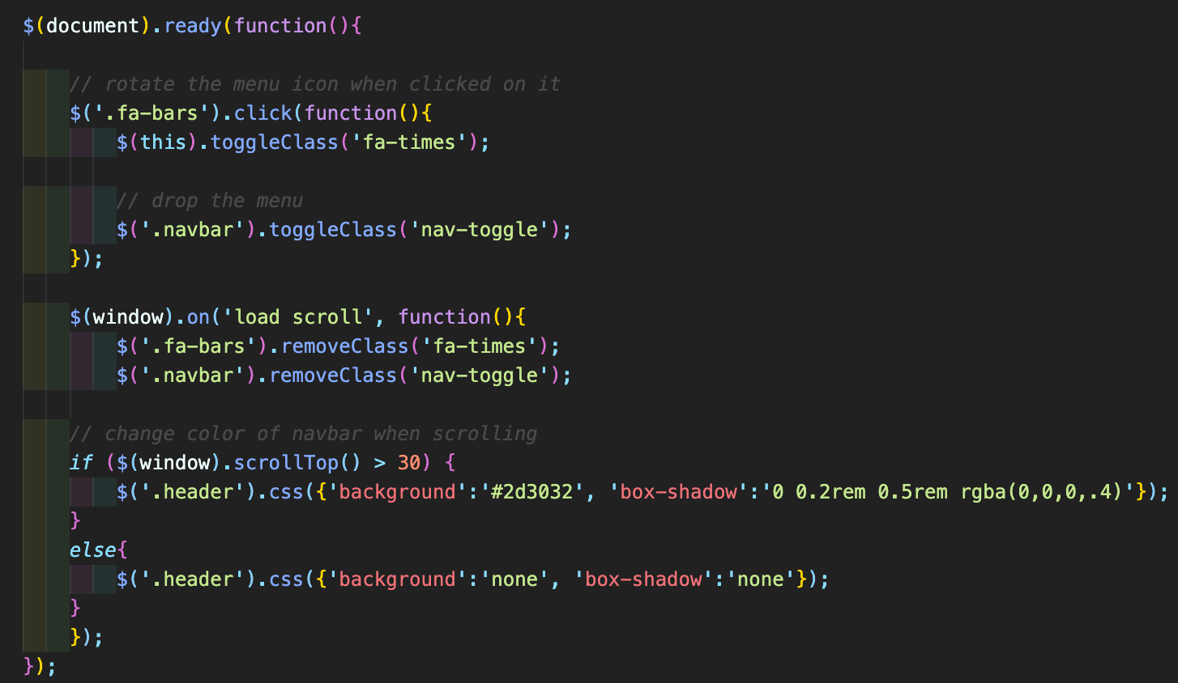

* .ready(function()):occurs when the DOM (document object model) has been loaded.
* .click(function()): simulates a mouse click on an element
* .toggleClass(function()): toggles between adding and removing one or more class names from the selected elements.
* .removeClass(function()): removes one or more class names from the selected elements.
* .scrollTop(): sets or returns the vertical scrollbar position for the selected elements.
* .css: sets or returns one or more style properties for the selected elements.

Double click on the video below to see the function’s output.

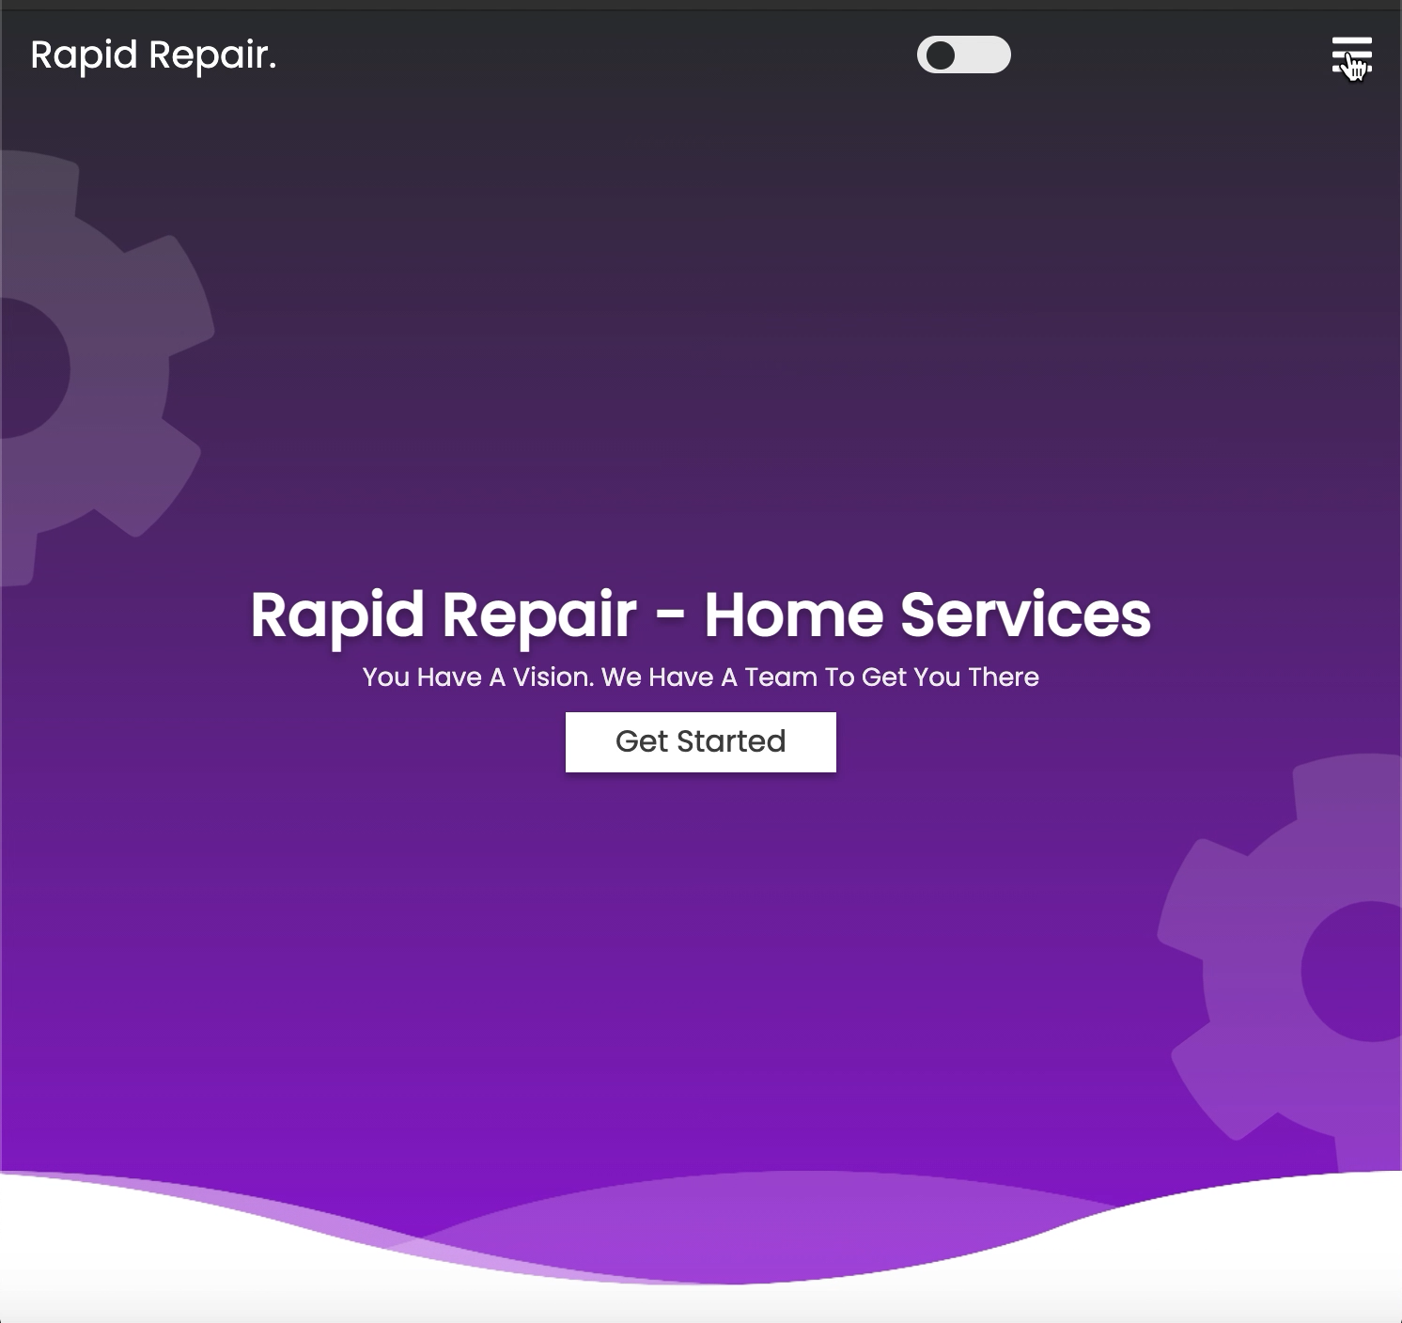

The second function, allows the arrow up button to scroll to the top of the page when clicked.

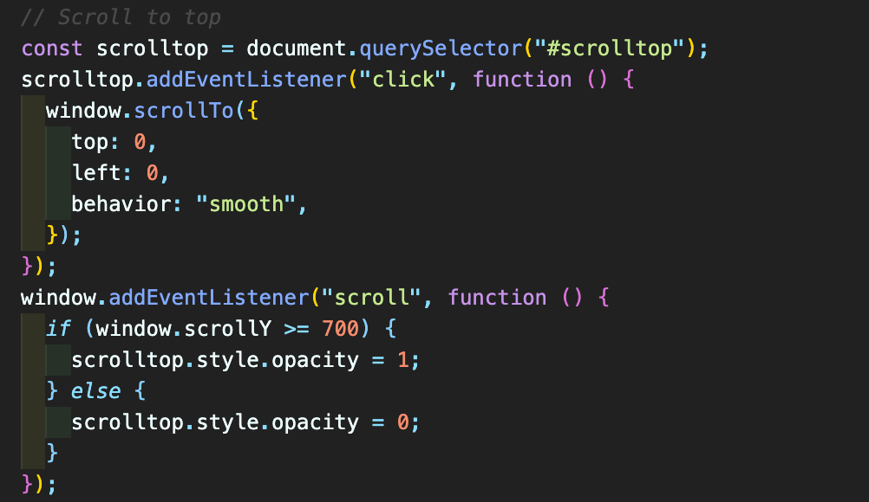

* const: defines a variable
* .querySelector(): returns the first element that matches a specified *CSS selector(s)* in the document.
* .addEventListener(function()):  sets up a function that will be called whenever the specified event is delivered to the target.

Double click on the video below to see the function’s output.

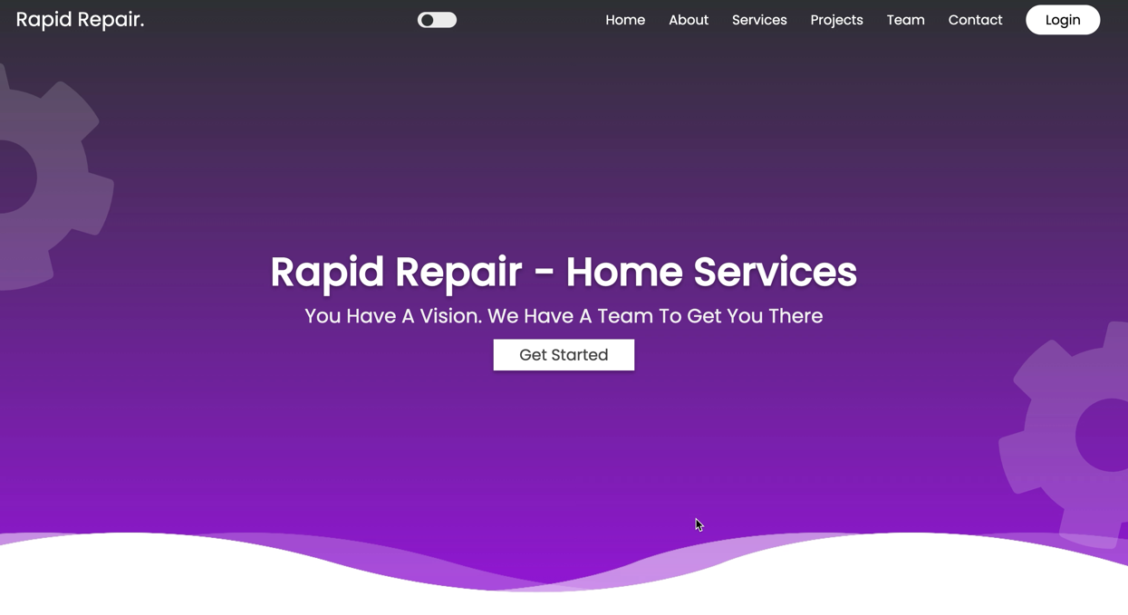

Finally, the last function in this page is responsible for the theme, when the ball button in the header is clicked the theme turns dark, and if it is clicked again the theme turns light.

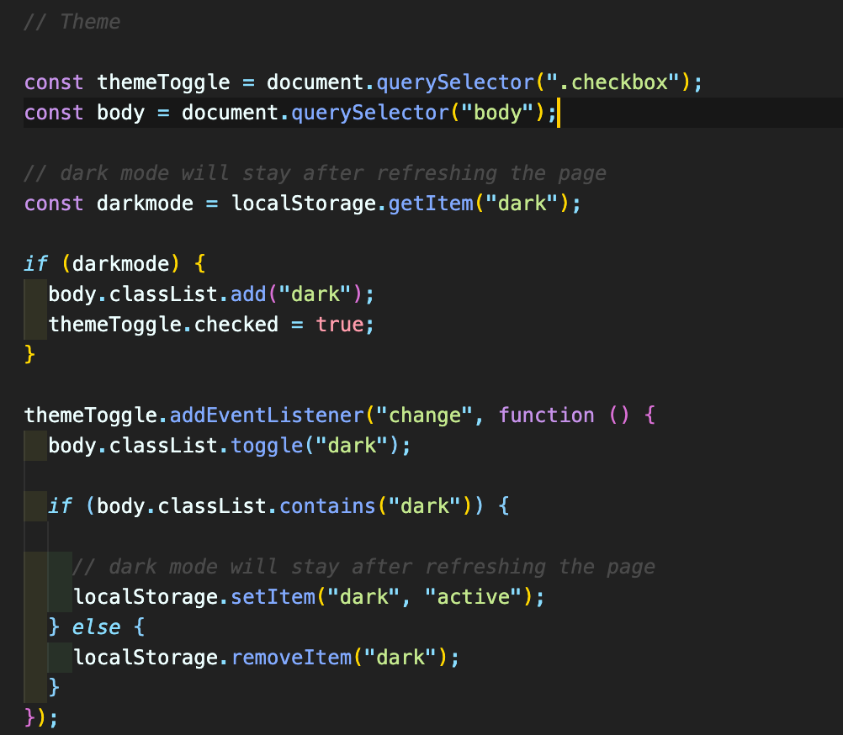

* localStorage.getItem(): Get the value of the specified local storage item:
* .ClassList: returns the class name(s) of an element, as a DOMTokenList object.
* .add(): find additional elements to add to the set of matched elements.
* .toggle(): hiding and showing an element
* .contains(): returns a Boolean value indicating whether a node is a descendant of a specified node.
* localStorage.setItem(): Set the value of the specified local storage item:
* localStorage.removeItem(): Remove the the specified local storage item:

Double click on the video below to see the function’s output.

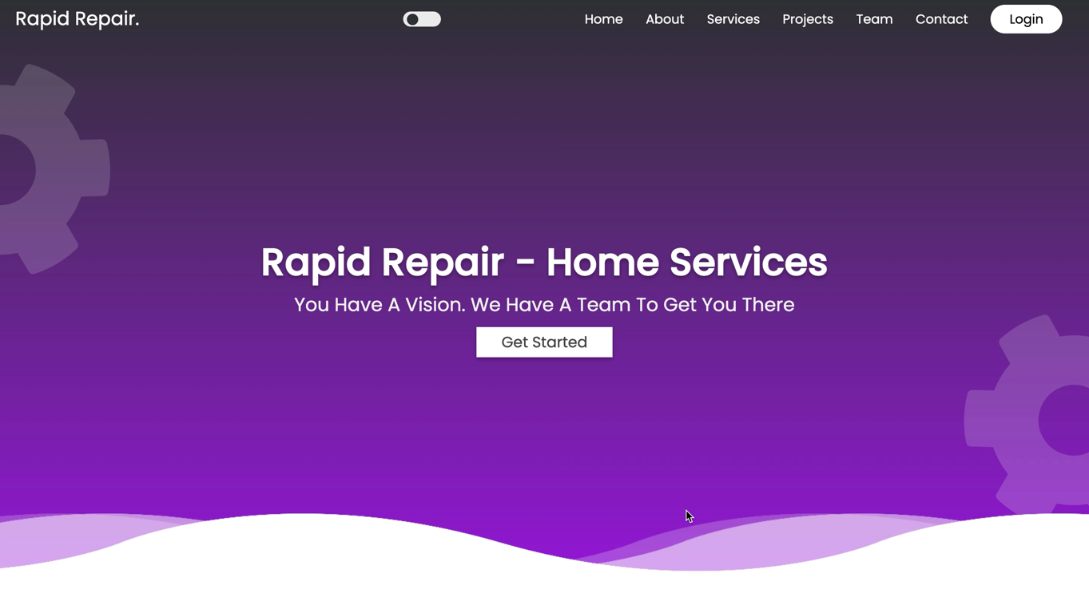

Now, the function in login and signup page is responsible for the form, whenever the user clicks an input field, a pink line slides from inner to outer and the icon changes color

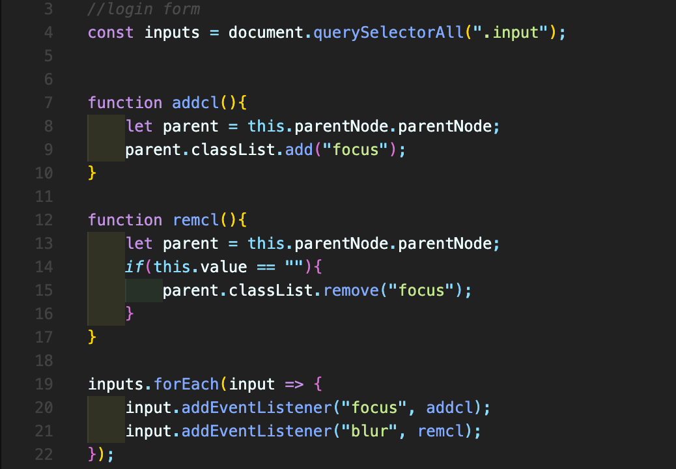

Double click on the video below to see the function’s output.

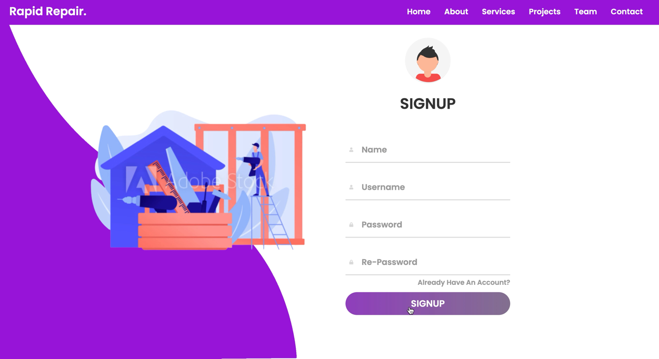

## php

In this section, I’ll clearly explain the php functions.

### login function

* An if statement to check if the user enter the data to store them
  + The validate functions implements the following
    - strip unnecessary characters (extra space, tab, newline) from the user input data
    - remove backslashes (\) from the user input data
    - converts special characters to HTML entities. If a user tries to enter some code in the form, it will not be executed
  + if they are not, an error message will be displayed and the user will be directed to the login page again.
  + if both are entered
    - the first validation that will be executed is to check whether the username is entered, if not it will redirect to the login page with an error. Same goes to the password.
    - If both are entered, it will hash the password. After that, an sql query will be created to check whether or not the username and password exist in the database.
    - After executing the query, it will check if the number of rows is 1,
      * If it is then the username and password exist,
        + it will check if they both match

if they do, it will login successfully

if not, it redirect to login page again with an error

* + - * if they do not exist it will redirect the user to the login page again with an error message.

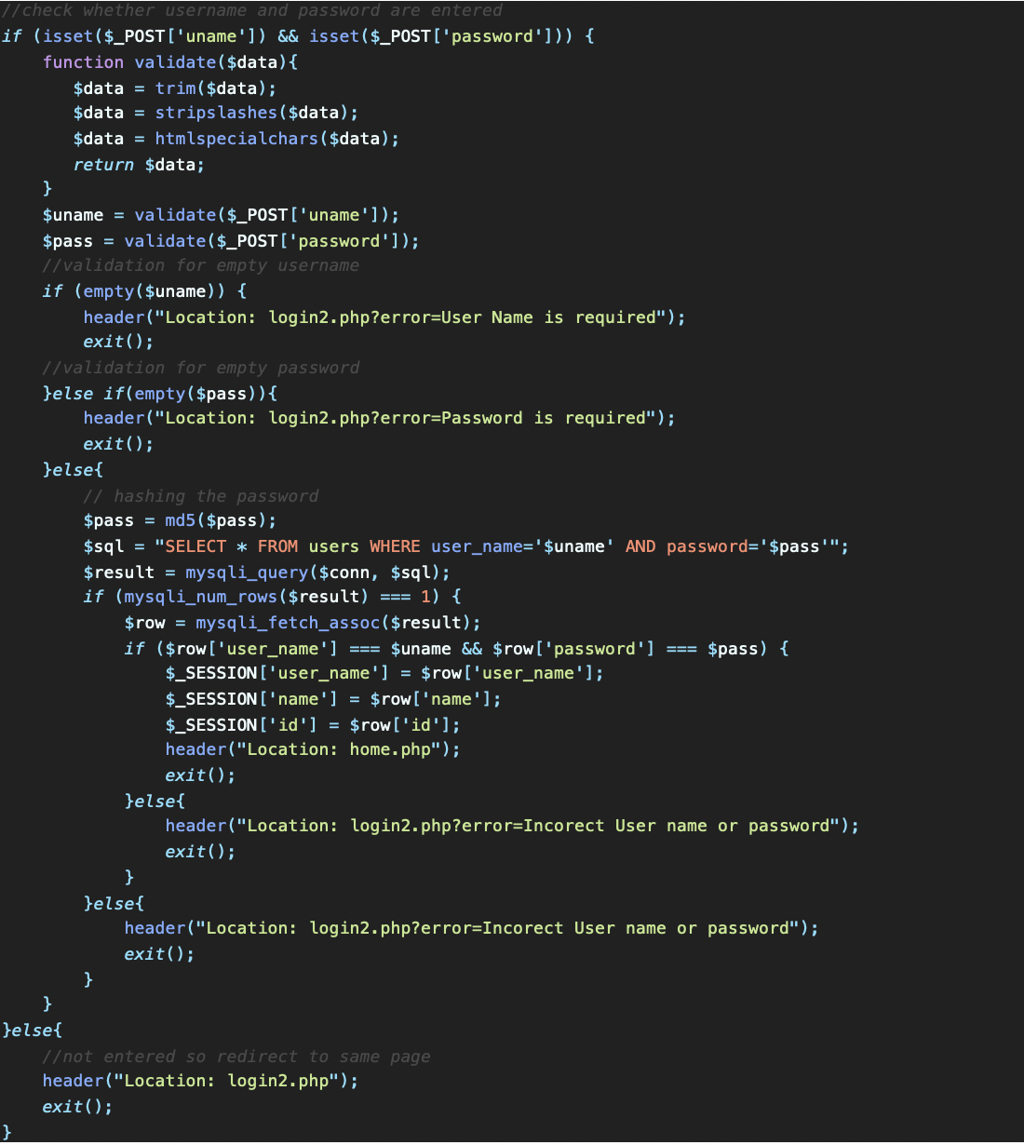

### signup function

The signup function starts like the login function until creating the second sql, the second sql with be created and then executed to insert/store the data in the database. If this process was successful the data will be stored and it will display a success message. However, if the process fails, it will display an error message.

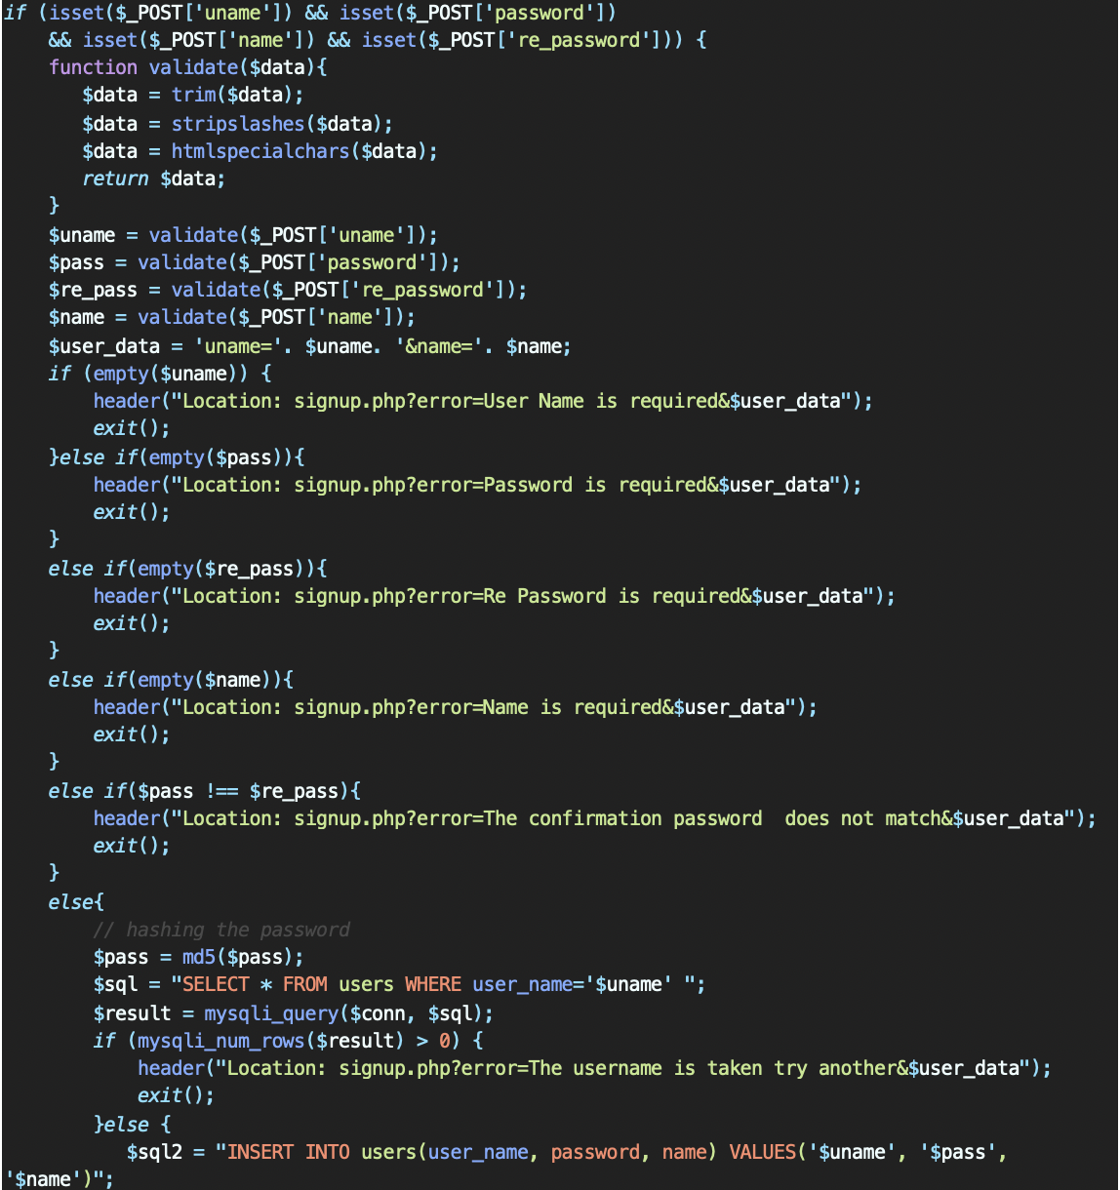

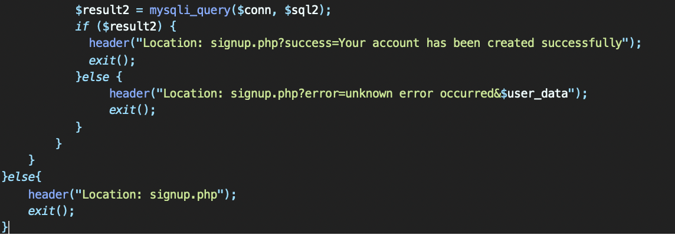

### ordering function

The ordering function almost follows the same steps as the signup, the following screenshot shows the function mysqli_real_escape_string, which prevents from sql injections.

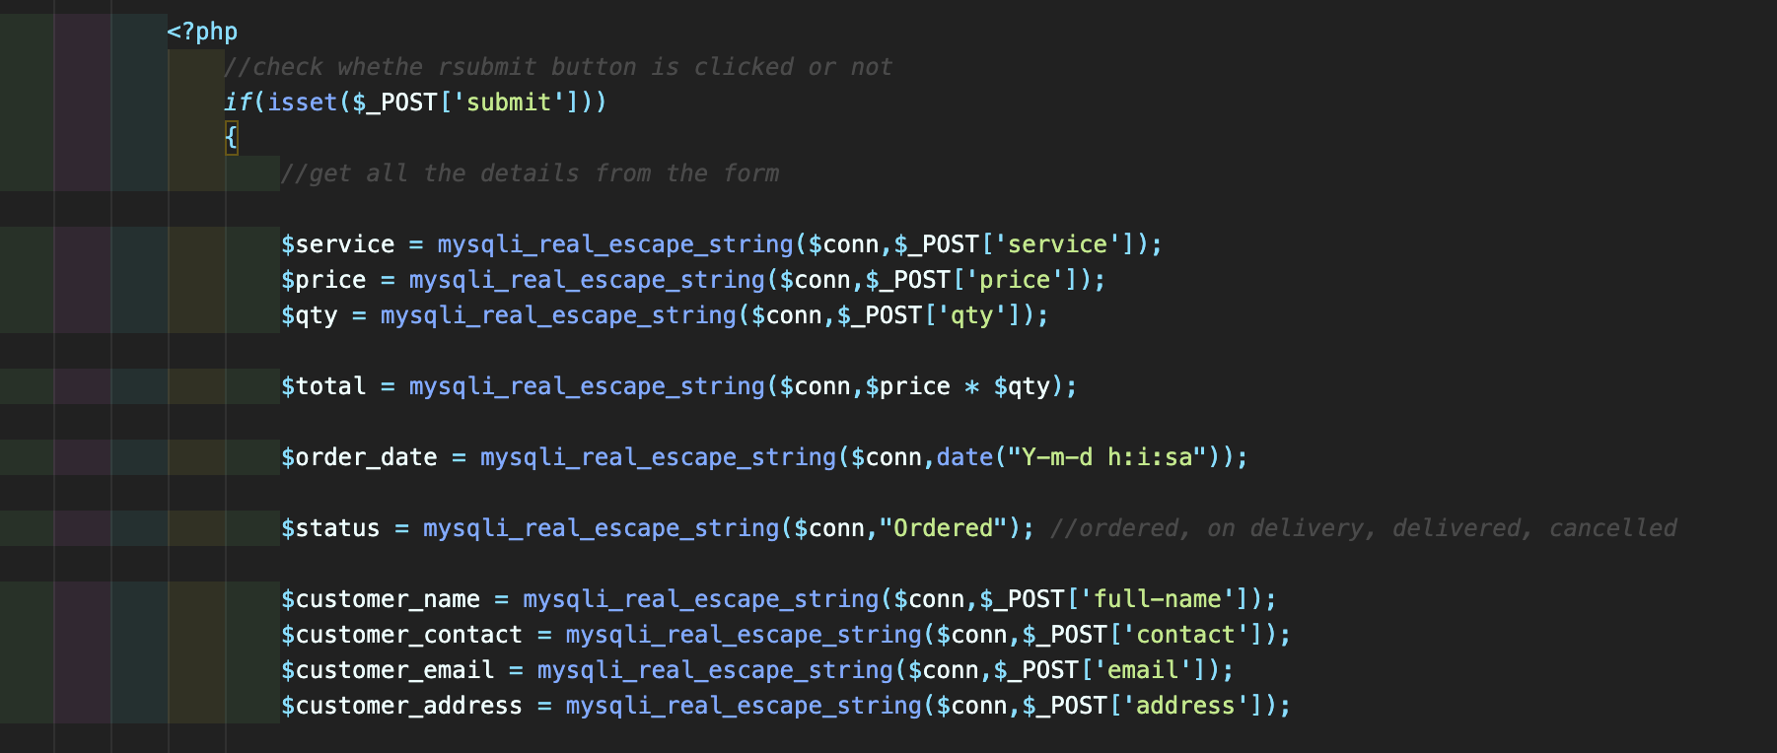

## admin functions

As mentioned earlier in the report, the admin can add, update, and delete categories and services.

### adding

The add function starts by an if statement to check whether the submit button is clicked or not. When it is clicked

* it get all the values from the form
* creates an sql query to insert the details in the category database
* executes the query and saves into the database
* checks whether the query was executed
  + if yes, displays a success message
  + if no, displays an error message

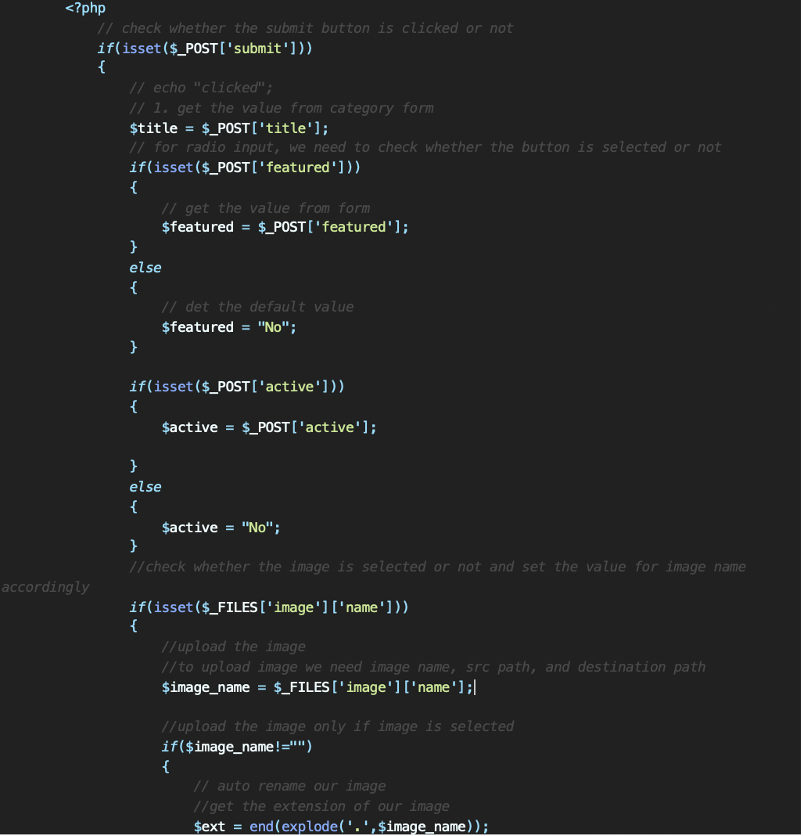

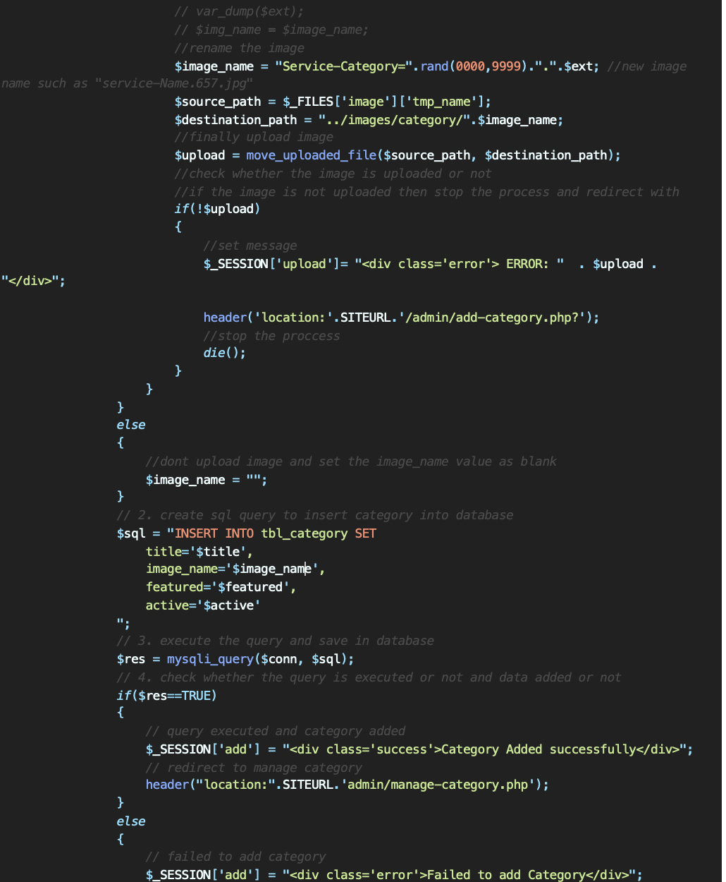

### updating

The update function starts by an if statement to check whether the submit button is clicked or not. When it is clicked

* it gets all the values from the form
* creates an sql query to update the category database
* execute the query and saves into the database
* checks whether the query was executed
  + if yes, displays a success message
  + if no, displays an error message

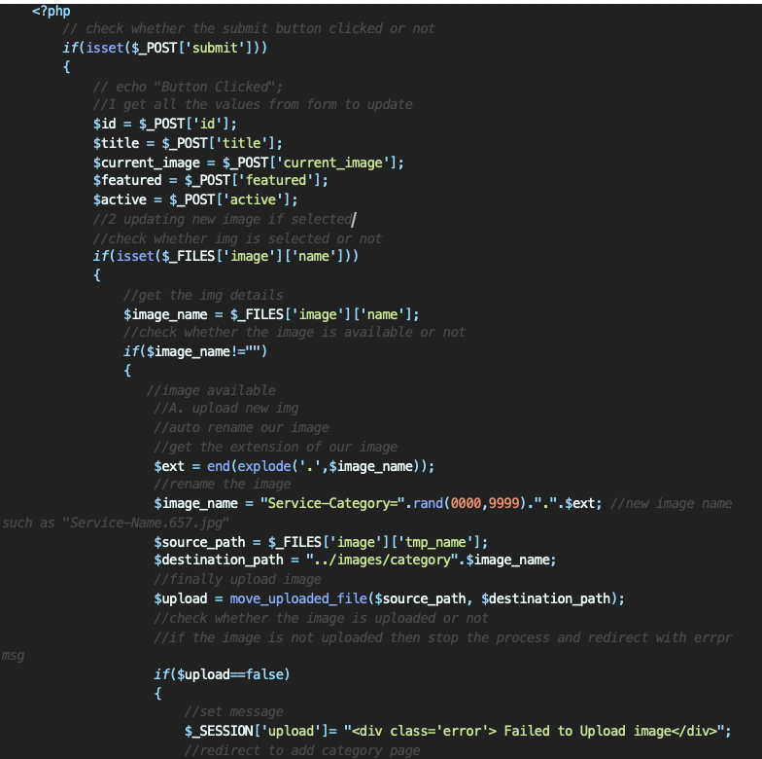

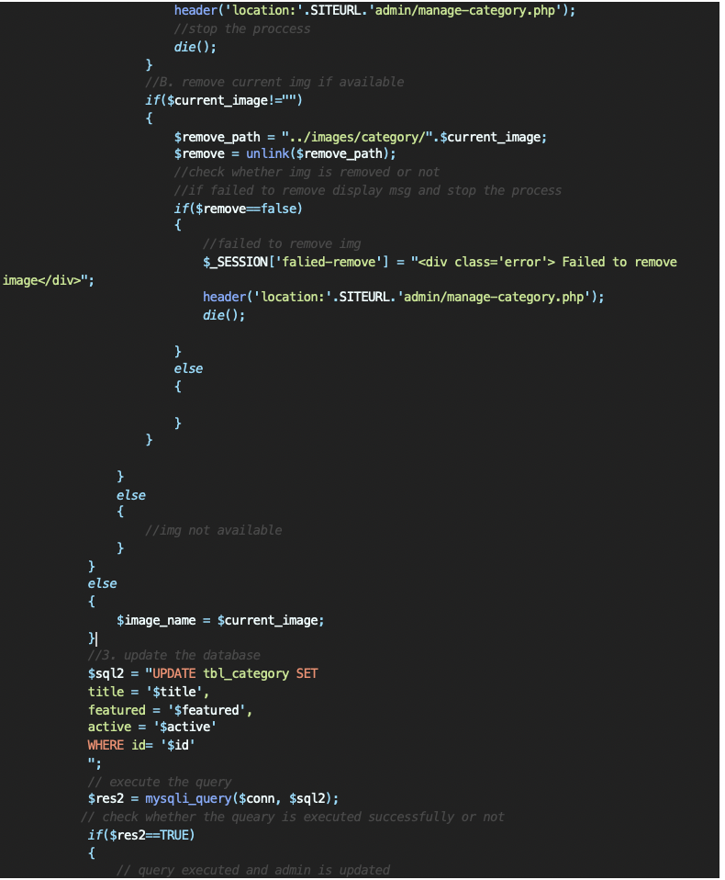

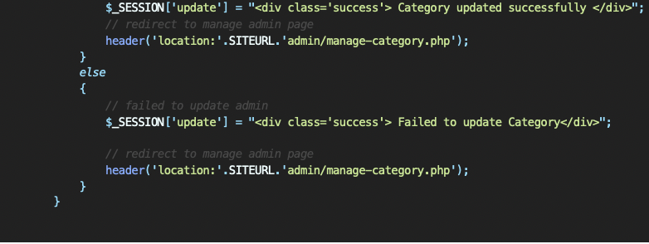

### delete

The delete function starts by an if statement to check whether the id and image are set

* it gets both values
* unlink the image path
* create sql query to delete from database
* execute the query to delete from database
* checks whether the query was executed
  + if yes, displays a success message
  + if no, displays an error message

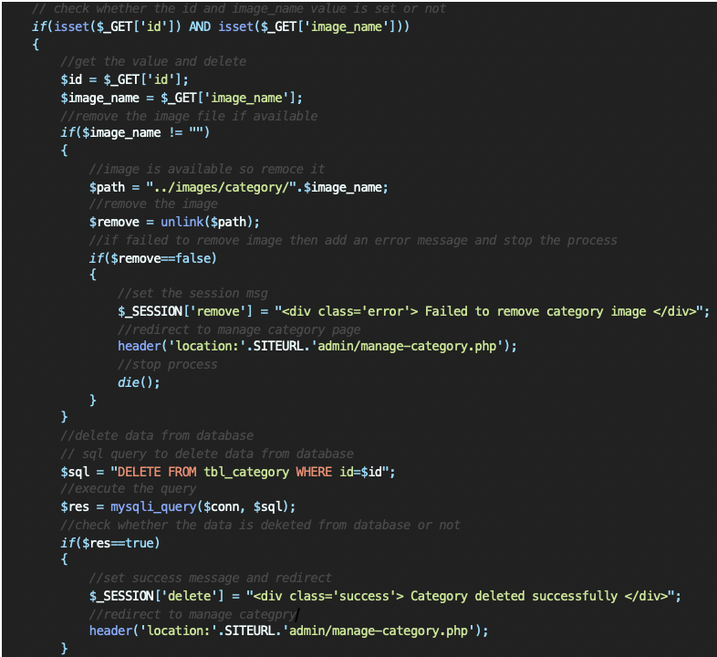

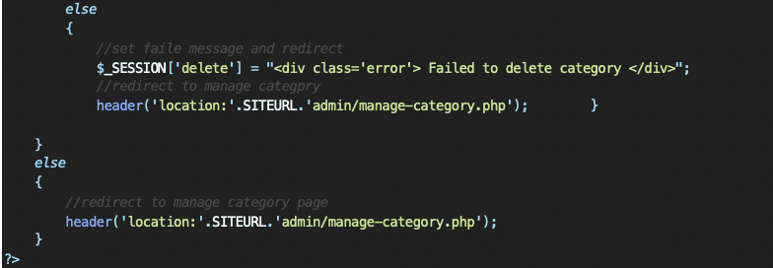

## sessions

Every page that should be accessed by a registered user starts with the following if statement,

*if* (isset($_SESSION['id']) && isset($_SESSION['user_name'])) { ?>

to ensure that the user is logged in.

Double click on the video below to see the function’s output.

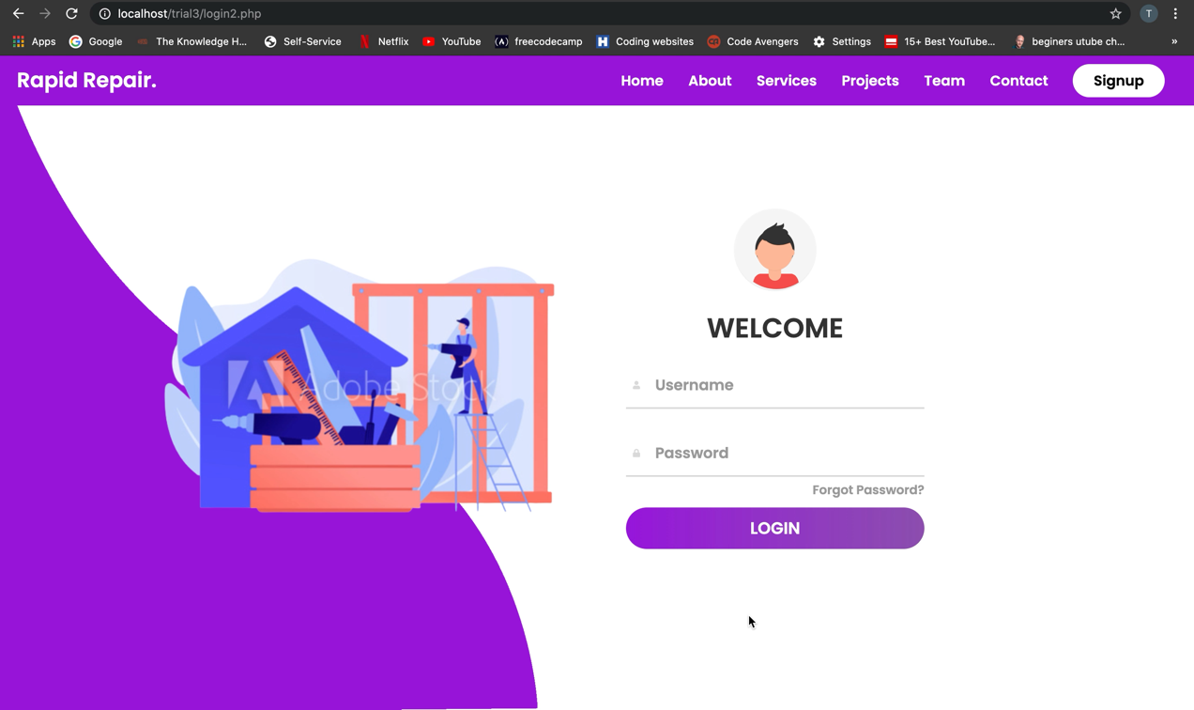

## cookies

setcookie() defines a cookie to be sent along with the rest of the HTTP headers.

setcookie("search_val",$search,time() + 84600) ;

cookies must be sent before any output from the script

$_COOKIE['search_val']

Double click on the video below to see the function’s output.

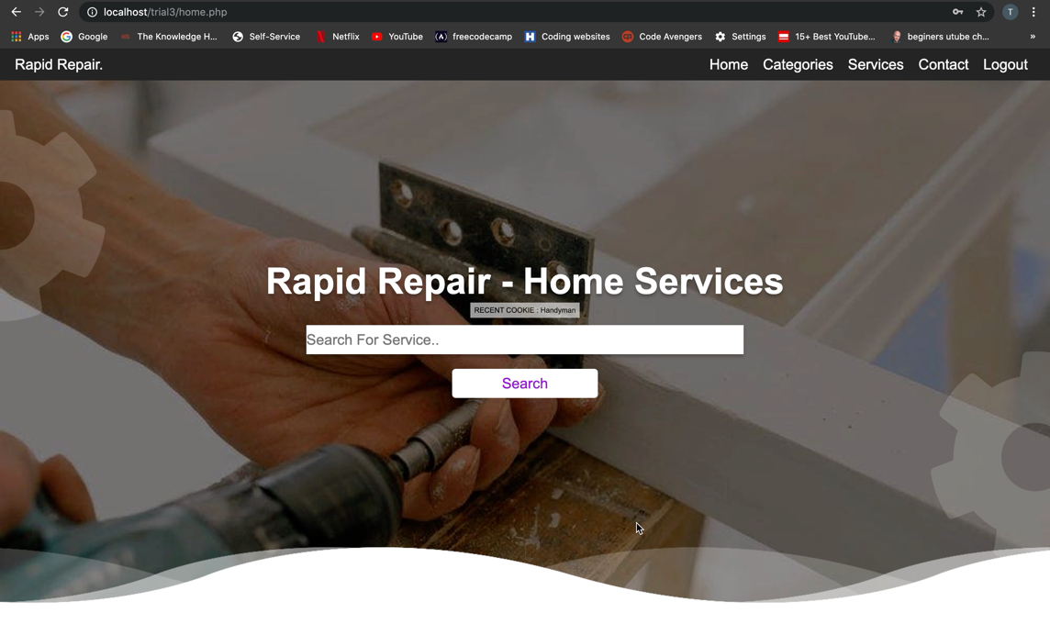

# prototype of the website

The website was precisely designed to be as user friendly as possible for the clients. It is a website where clients will be able to create their own account and easily order any home service available by filling a simple form. Now, the website point of users view will be clearly explained.

The header includes the theme, Home, About, Services, Projects, Team, Contact and Login button. The logout button will be used once the user logins the website.

Theme: the theme button will convert the whole page to dark mode theme and if the user wishes to convert it back to light theme they click on it again

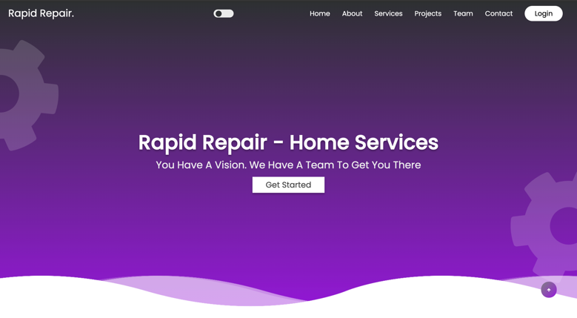 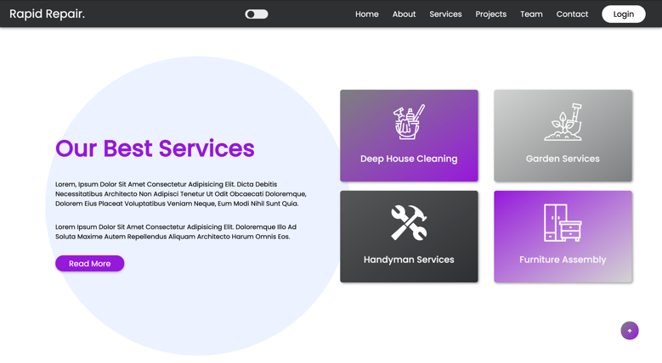

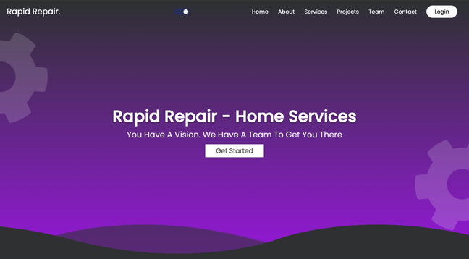 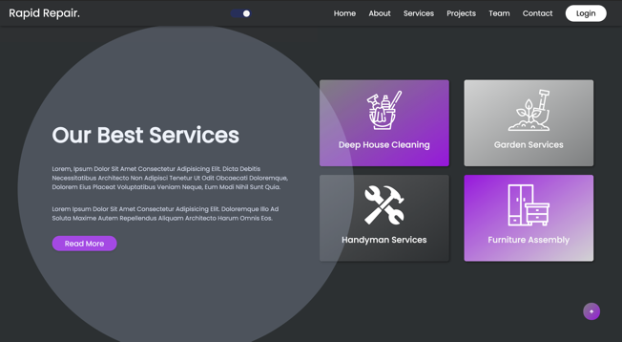

Index: calls the index page, which is in the screenshot below. In this section, the get started button will direct the user to the registration page.

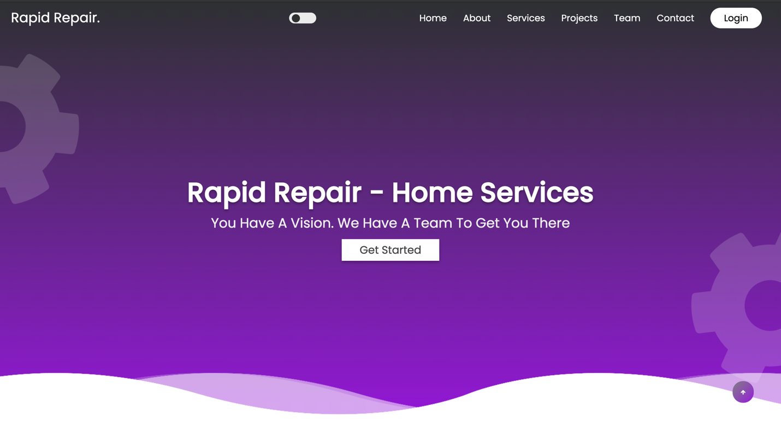

About: calls the about section in the home page, which is in the screenshot below. In this section, the read more button will direct the user to the registration page.

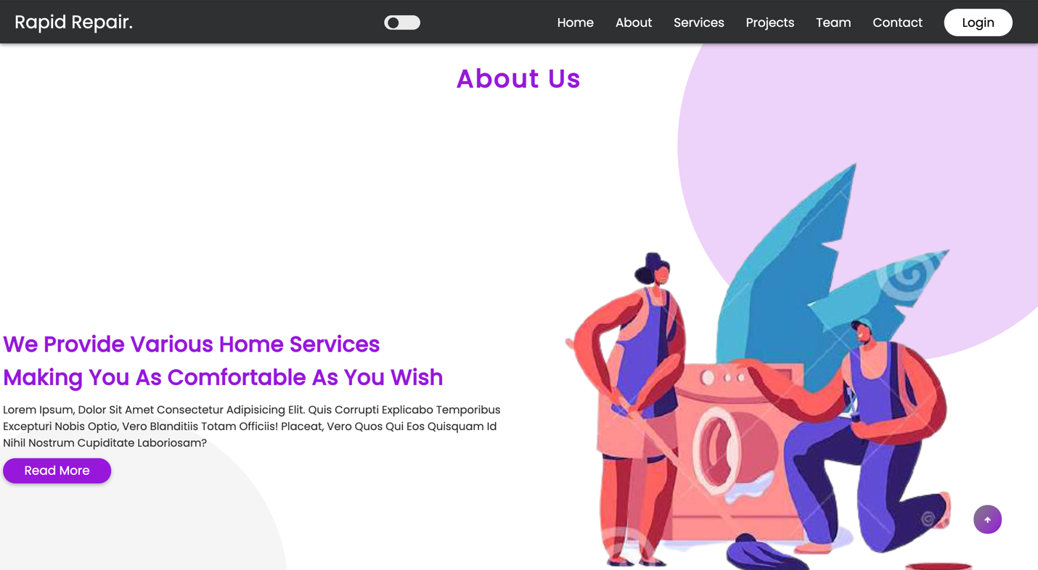

Services: calls the services section in the home page, which is in the screenshot below . In this section, the get started button will direct the user to the registration page.

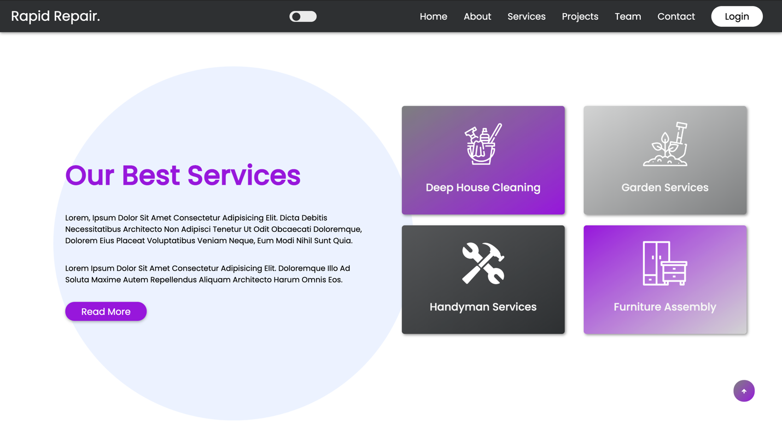

Projects: calls the projects section in the home page, which is in the screenshot below.



Team: calls the team section in the home page, which is in the screenshot below.



Contact: calls the contact section, which is the footer, which is in the screenshot below.

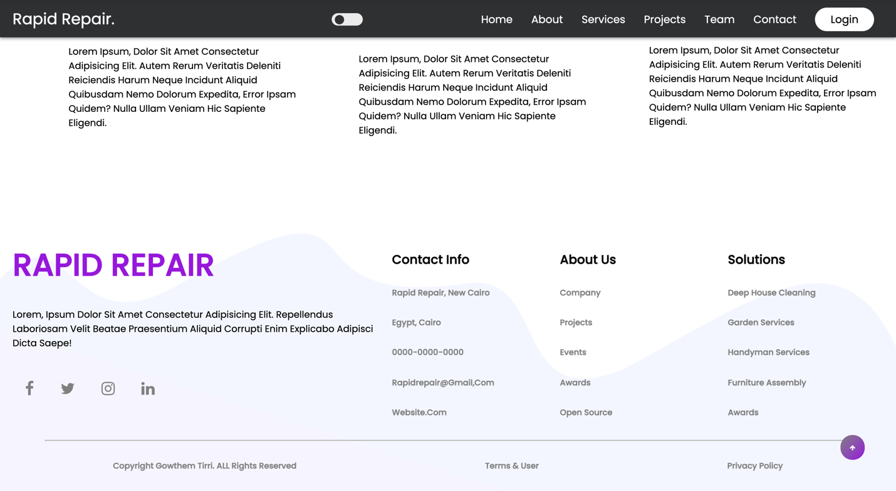

Register page: when a client will click on read more or get started button, the register page will come up. If the user is new, they will have to fill the form in order to continue with the procedure. If the user is already registered they can click on the Already have an account link.

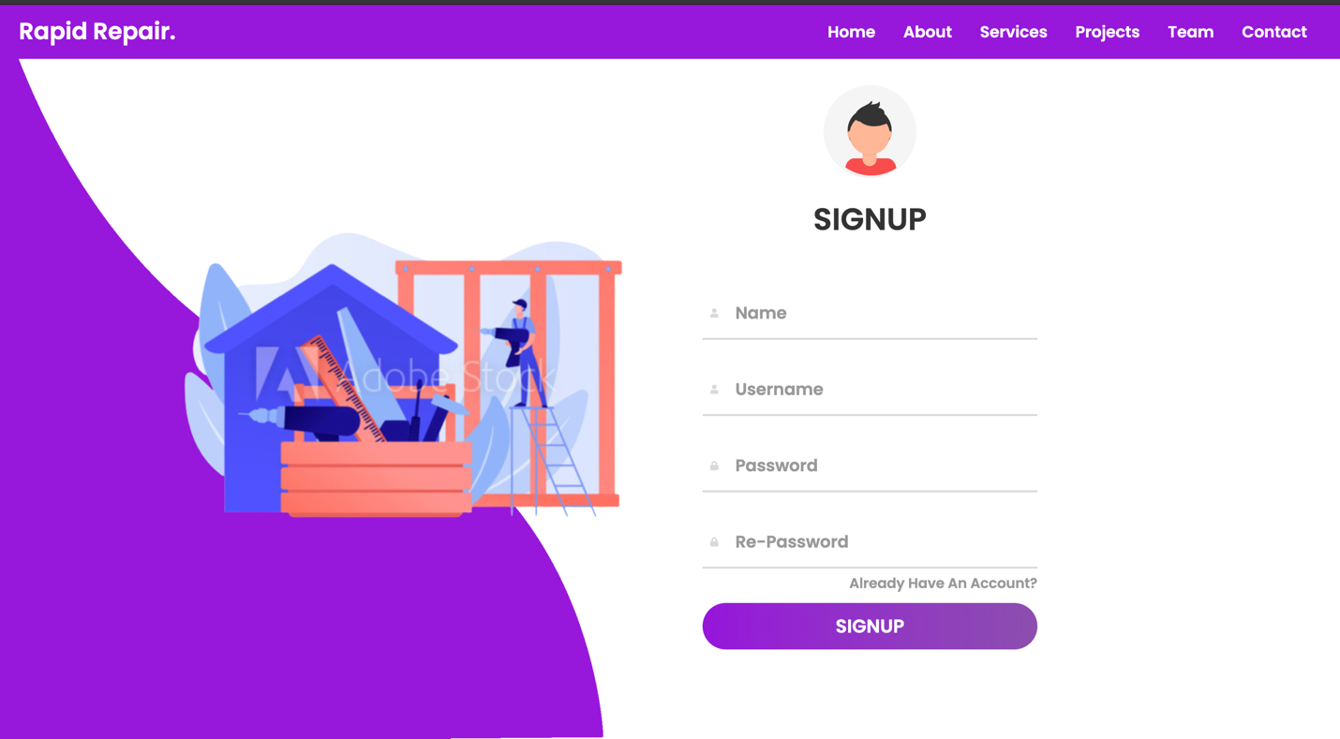

The user should fill all the fields and make sure the confirmation password matches the password in order to complete the registration procedure. If the procedure is not carried out in the right way, an error message will be displayed. After that, by clicking the signup button, your account will be registered and only then will you be able to login to the system. After the procedure is done, a success message will be displayed and the user can now head to the login page to login.

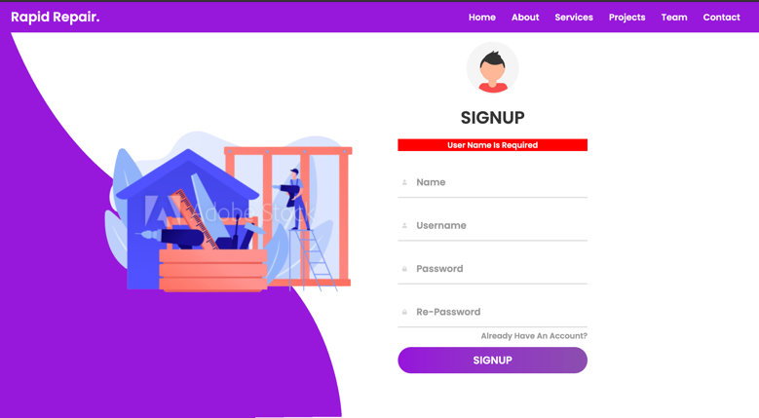 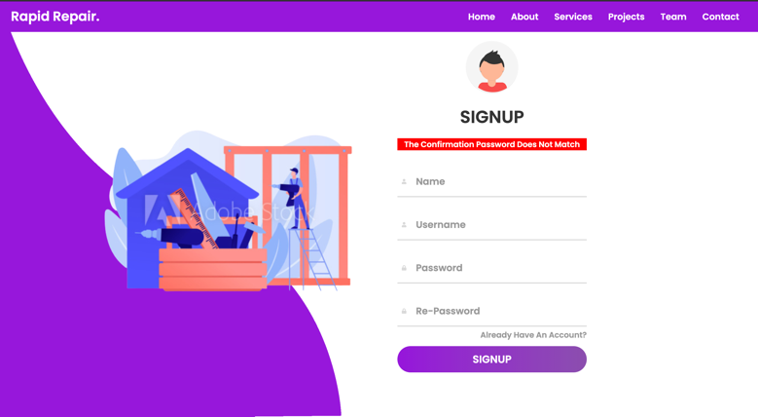

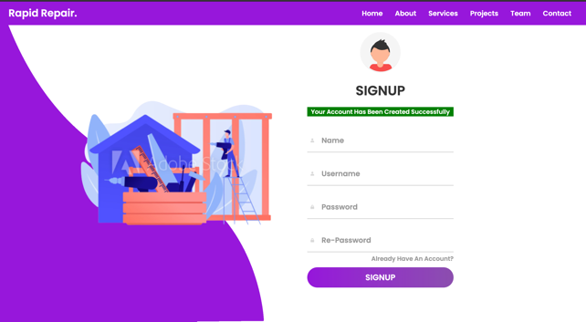

Login page: In the login page, the user will simply enter the username and password they registered with. If the user is still not registered, they can click on the signup button. After the completion of this step, the user will be allowed to access the rest of the website and a logout button in the header will be displayed for the user to log out anytime.

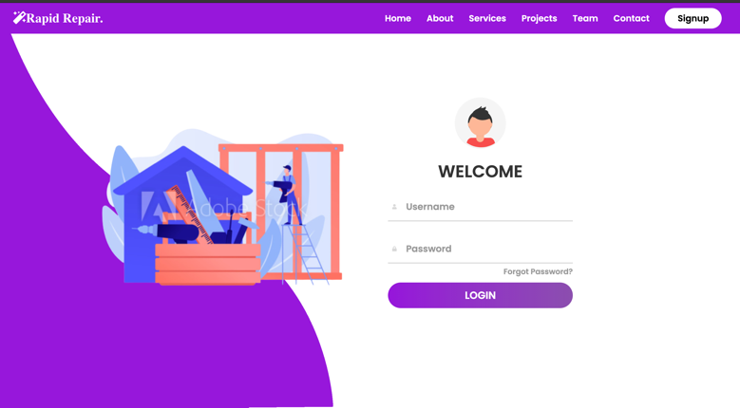 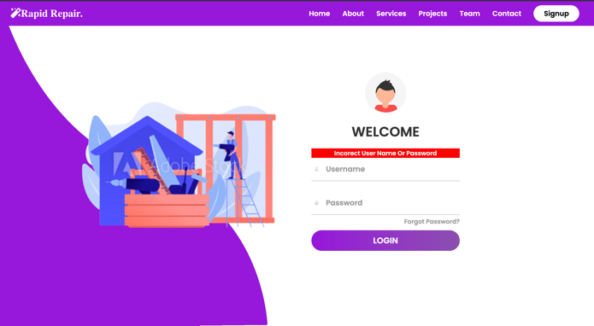

Home page: After the user logins successfully, they will be directed to the home page. The Home, Categories, Services, Contact and Logout button are included in the header. The logout button will allow the user to log out and end the session.

The home page is divided into three sections.

* The search section: In this section the user will be able to search for services. When the user searches for anything such as clean, they will be directed to the service-search page which will display the services related to the keywords entered.

 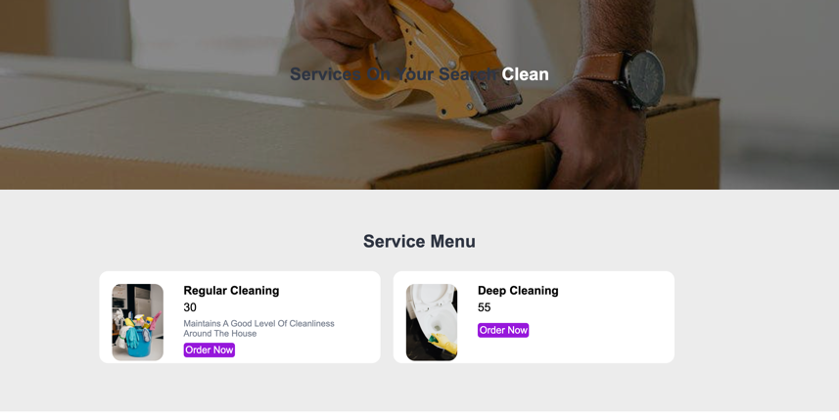

* The explore services section: in this section, at most three categories will be displayed. When the user clicks on any category, they will be directed to the category-service page, which will display all services related to the category chosen.

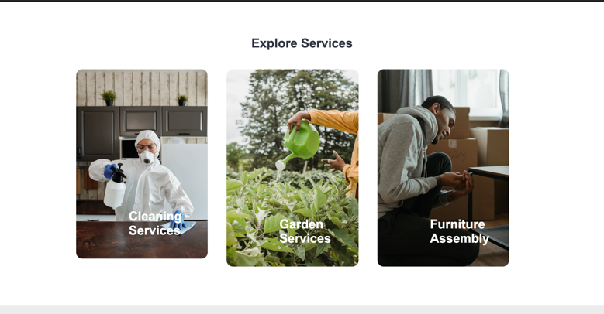 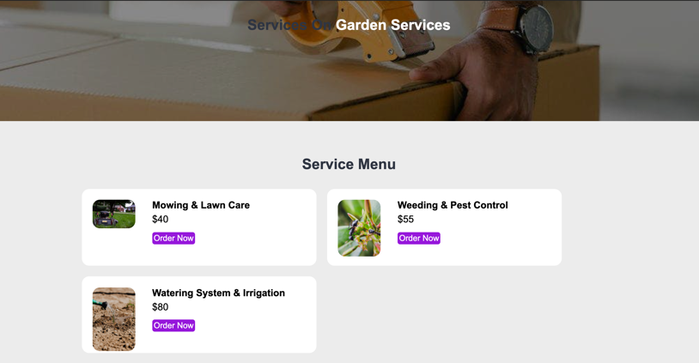

* The Service Menu Section: In this section, at most 6 services will be displayed. When the user clicks the order now button, they will be directed to the order page where they have to fill a form to place an order.

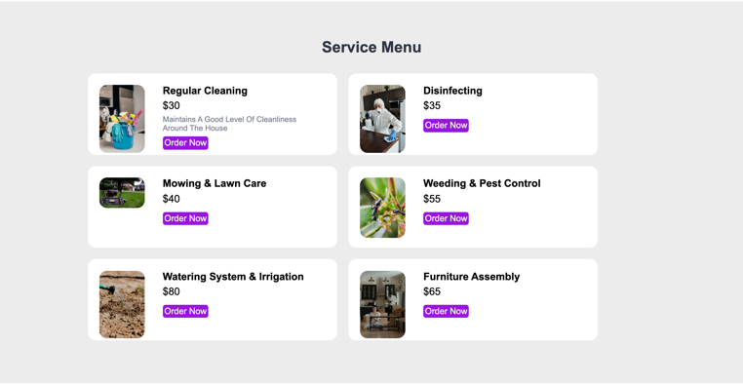 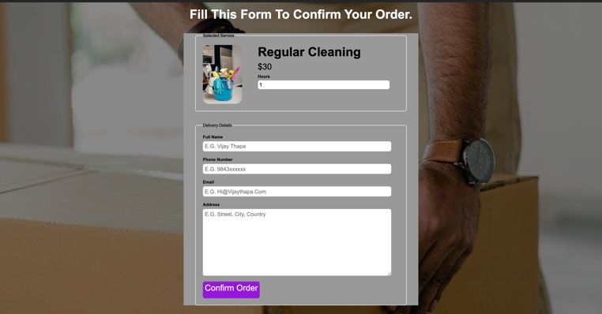

# Conclusion

In conclusion, the website’s output met my expectations as well as the coursework’s requirements. It is designed perfectly for anyone to use it as an ordering website. The website contains many options for the admin to easily add, delete, and update categories and services on the website to meet the objective. Moreover, it gives the user options including to create an account and order online.

At the beginning of this assignment, I had very little experience with web development and databases so a large portion of time was dedicated to research, understanding and testing, as well as looking at alternative implementations to figure out what was most efficient. Finally, this made me improve my web development skills and it also enhanced my problem solving skills as I used the try and error method a lot.